**Ideation Phase**

|  |  |
| --- | --- |
| Date | 29 September 2022 |
| Team members | Kirthik S  Oyndrisha Rakshit  Oviya  Hari Priya c |
| Project Name | Project- Deep Learning Fundus Image Analysis for Early Detection of Diabetic Retinopathy |
| Maximum Marks | 2 Marks |

**Introduction:**

Diabetic Retinopathy (DR) is a common complication of diabetes mellitus, which causes lesions on the retina (back of the eye) that affect vision and If it is not detected early, it can lead to blindness. Diabetic retinopathy (DR) indicated that a significant number of patients with diabetes failed to have recommended annual eye examinations due to long examination times, lack of symptoms, and limited access to retinal specialists. One of the efforts to resolve these barriers is the application of artificial intelligence (AI) techniques for DR detection and diagnosis.

**Problem Statement:**

1. A person who is a Diabetic Retinopathy patient needs to check her severity level because she is worried about her sugar level maintenance.

2. A person who is a teacher by profession needs a way to ensure herself that she is not suffering from Diabetic Retinopathy by taking up a test which is cost efficient and time saving.

3. An ophthalmologist by profession needs to diagnose a patient with Diabetic Retinopathy using some technology so that he can conduct camps to help with early detection

**Questions:**

1)Who does this problem affect?

Problem arises for people with diabetes.

2)What are the common symptoms?

Early stages there are no significant symptoms or only mild vision problems.

3)When does the issue occur?

Issue occurs in the eye when blood vessels of light sensitive tissues are damaged.

4)Why is it important to fix the problem in early stages?

The problem if identified early with proper treatment permanent blindness can be avoided.

5)What are the current methods to diagnose?

Current diagnose methods are mostly manual and are prone to human error.

**Example:**

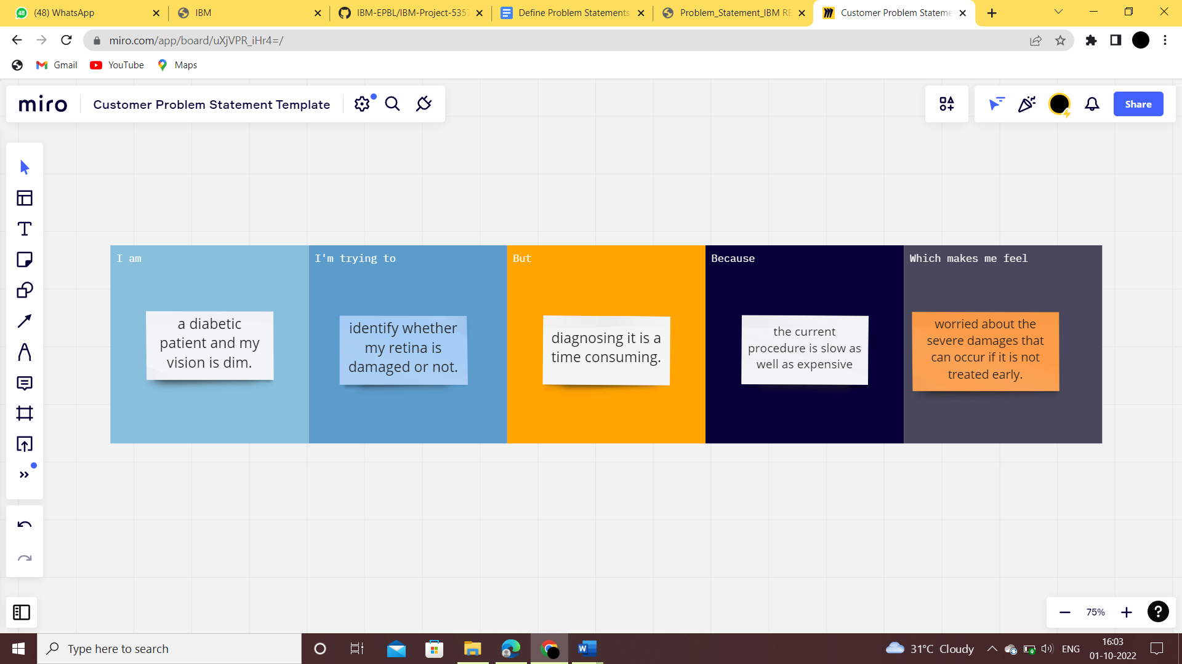

|  |  |  |  |  |  |
| --- | --- | --- | --- | --- | --- |
| **Problem Statement (PS)** | **I am (Customer)** | **I’m trying to** | **But** | **Because** | **Which makes me feel** |
| PS | Diabetic patient | Identify whether my retina is damaged or not | Diagnosing it is a time consuming. | The current procedure is slow as well as expensive. | Worried about the severe damages that can occur if it is not treated early. |